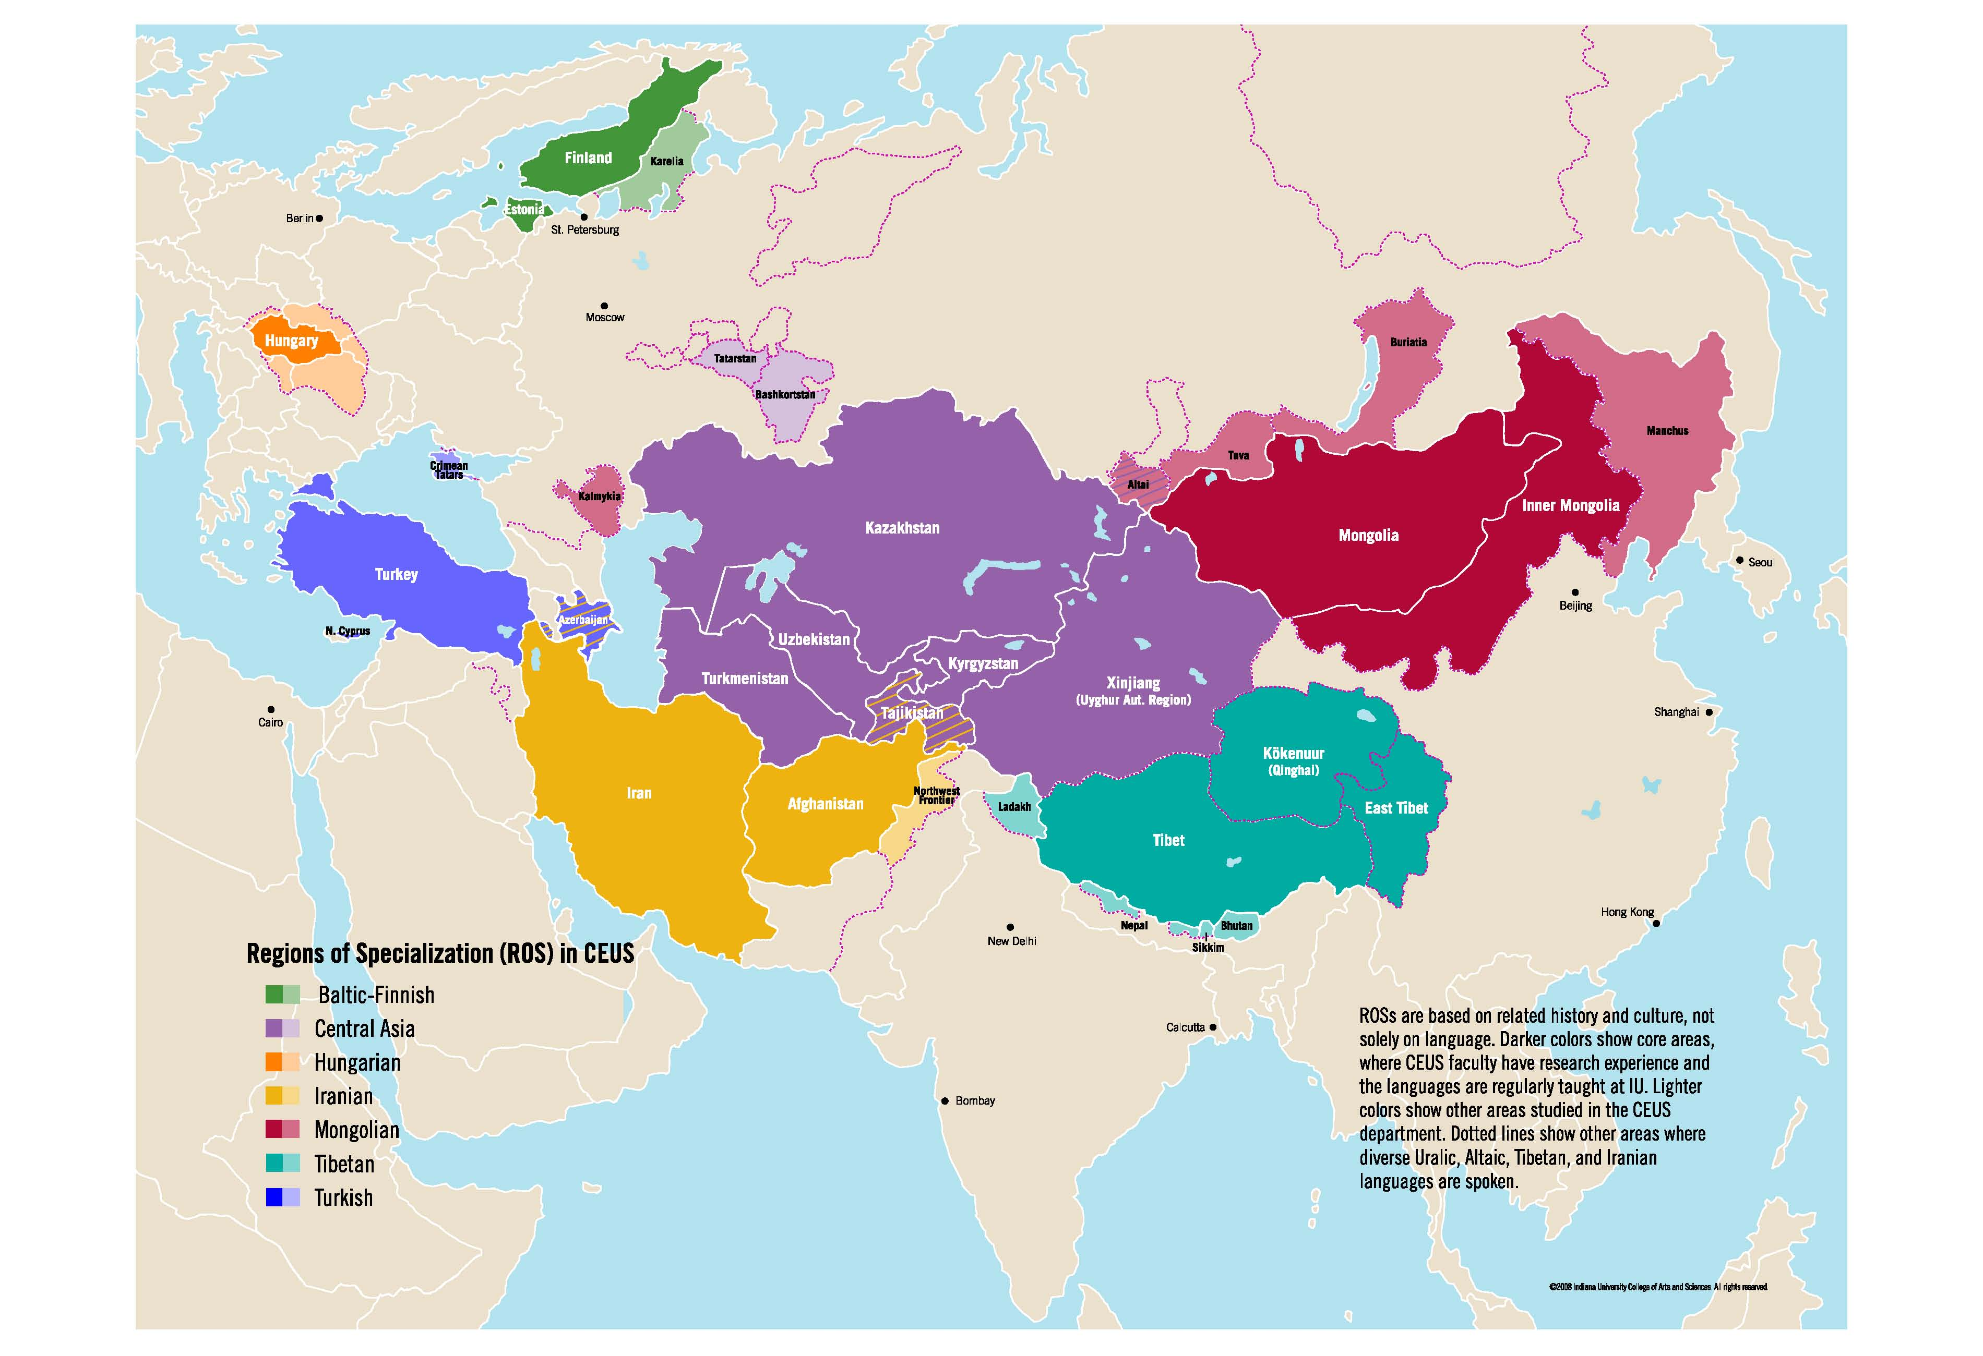
REGISTRATION FORM
Placement and Proficiency Exams
Department of Central Eurasian Studies (CEUS)

The Department of Central Eurasian Studies offers placement and proficiency exam services.
This service is free of charge for IUB students. Please read the instructions carefully for both types of exams to determine which one applies to you.

IUB students: Please provide all the information requested below. Return the completed form as an e-mail attachment to ceus@indiana.edu with subject line Language Exam. Registration deadline for Fall 2019 testing is 5 PM on Wednesday, August 21. The department will confirm your request by e-mail.

Non-IU students: Please provide all the information requested below and send as an email attachment to ceus@indiana.edu with subject line Language Exam. The department will confirm your request by e-mail.

If you have any questions, please contact ceus@indiana.edu or call (812) 855-2029.

PLACEMENT EXAMS
Placement Exams are designed for both undergraduates and graduates with any language experience (formal or informal) to determine the level of your Fall 2019 CEUS language course. The Placement Exam is required for native and heritage speakers.

PROFICIENCY EXAM
Undergraduates: Complete if you wish to test out of intermediate level to fulfill a language requirement. This includes heritage speakers.

Graduates (CEUS majors): Complete if you wish to test out of your Language of Specialization.

Graduates (non-CEUS majors): Complete if you wish to test out of a CEUS language to fulfill your graduate reading proficiency requirement.

EXAM DATE: (Registration Deadline: 5 PM, Wednesday, August 21)
Friday, August 23, 9am-10:45pm-written exam; Hamilton Lugar School of Global & International Studies room 4067. Please arrive by 8:45 AM.
Friday, August 23, oral exam immediately following written; location announced at the written exam
A picture ID is required on day of testing. The picture ID name must match your name in One.IU

REGISTRATION FORM:
□ Placement Exam I hope to place into: □ Intermediate ◻ Advanced
□ Proficiency Exam I hope to test out of: □ Introductory □Intermediate □Advanced

First Name: Last Name: UID number:
IU e-mail address:
Department/Major (if known): Status (graduate or undergraduate):
Language to be tested:
Explain relevant experience you have in this language (length/intensity/form of study, relevant language exams, etc.)

